ID#: 620129338

**Economic Development I**

Course Code: ECON 6032

**Insights into Aspirations: The Impact of Educational Aspirations on Women's Desired Family Size**

**By Dalkeith Thomas**

**December 2023**

**Abstract:** This research explores the intricate relationship between women's educational aspirations and desired family size, delving into the multifaceted dynamics that shape fertility choices. Using a General Poisson Regression model, we examine the impact of educational aspirations, education, religiosity, employment, and other factors on women's preferences regarding the number of children they wish to have. Findings reveal a significant and negative correlation, between aspirations and the number of children women desire to have, highlighting the influence of educational pursuits on fertility trajectories. Moreover, the research contributes to the existing literature by presenting a forward-looking model for understanding the complexity of women's aspirations and reproductive decisions. This study provides valuable insights for policymakers and researchers interested in the intersection of education, career, and family planning, emphasizing the need for tailored support structures to accommodate the diverse aspirations of women in modern societies.

**JEL Classification Numbers:** **D13, J13, J16, I21**

**Keywords:** **Educational Aspirations, Education**

**Table of Contents**

**1.** **Introduction** 3

**2.** **Literature Review** 4

**2.1 Theoretical Literature** 4

**2.2 Empirical Literature** 6

**3.** **Data** 7

**4.** **Methodology** 8

**5.** **Estimation results and analysis** 10

**6.** **Limitations** 17

**7.** **Conclusion** 18

**8.** **Policy recommendations** 18

**References** 20

**Appendix A1** 23

# **Introduction**

In the realm of decision-making, few choices carry as much gravity and enduring significance as those concerning fertility and education. For women, these choices often bear heightened importance due to the physical and mental toll of pregnancy and the opportunity costs associated with childbearing. The relationship between fertility and education in women is crucial for a developing economy as it enhances human capital, boosts workforce participation, fosters women's empowerment, and collectively contributes to sustainable economic growth.

Mills *et al.* (2011) underscores that both child-rearing and pursuing advanced education are perceived as time-intensive commitments, necessitating a trade-off between the two. Additionally, higher levels of education correlate with greater potential lifetime earnings, enhancing financial independence and bolstering decision-making autonomy in family planning, as highlighted by Lutz (2006). Hence, rather than being compelled into the responsibilities of child-rearing, women today possess greater agency when it comes to making decisions that have the potential to profoundly impact the course of their lives. Thus, a notable trend has emerged among women residing in both developing and developed nations, wherein they opt to postpone childbirth in favor of pursuing advanced educational pursuits (Kemkes-Grottenthaler, 2003).

This study seeks to address the question of whether women with heightened levels of educational aspirations exhibit a preference for smaller family sizes in contrast to women with more modest educational aspirations. Additionally, the research aims to explain the relationship between education and various demographic factors on the number of children women desire to have. The framework presented herein takes a future-oriented approach. Unlike other models that incorporate existing education and its influence on fertility, this model delves into the realm of educational aspirations and its potential impact on fertility. This approach, while bearing certain advantages, is not without its limitations. Notably, it acknowledges the inherent unpredictability of the future, with an individual’s decisions and responses being contingent upon their current perspectives. However, it also offers explanatory value, as it pertains to the newer generation of parents and members of society who grapple with present decisions and anticipate forthcoming challenges. It encompasses the choice of potentially investing in further education, which could conceivably exert an influence on family size. In this context, the researcher posits that educational aspirations will emerge as a significant and negative determinant of the number of children women desire to have. This contribution augments the ongoing discourse but within the specific context of a Small Island Developing State.

The subsequent sections of the paper are organized as follows: Section 2 provides an in-depth review of the literature on the relationship between fertility and education, whereas Section 3 delineates the data utilized in the study. Section 4 articulates the methodology employed, and Section 5 expounds upon the presentation and discussion of the principal findings. Section 6 elaborates on the limitations encountered. Whereas Sections 7 and 8, furnish the concluding remarks and policy recommendations respectively.

# **Literature Review**

# **2.1 Theoretical Literature**

Debatably, the most popular model in fertility economics which investigates the relationship between income and fertility is the quantity-quality theory (Becker, 1960). Though income is not synonymous with education, they are closely related (Griliches & Mason, 1972). The theory starts with the premise that parents face an opportunity cost of time. The time spent on childbearing and child-rearing could be used for other activities, such as work or leisure. There is a trade-off between the number of children a family has (quantity) and the resources invested in each child (quality). As parents allocate more time and resources to childbearing, there are fewer resources available to invest in the well-being and education of each child. Changes in income and prices can influence the trade-off between quantity and quality. An increase in income might lead to a substitution effect, where parents allocate more resources to the quality of children and have fewer children. However, increased earnings changes can also have an income effect, where increased income might lead to an increase in both the quantity and quality of children. The net income effect on fertility depends on the relative strength of the income effect relative to the substitution effect. Becker (1991) further asserts that modern economies greatly reward educational prowess. Given the substantial costs associated with continuing education for parents, they will maximize utility at a lower fertility level but a higher level of education when compared to earlier economies where returns on investment in human capital were lower.

Contrary to prevailing notions, Doepke *et al.* (2022) contend that the established inverse correlation between fertility and education, pervasive within the literature, is undergoing attenuation and, in certain instances, complete reversal. The authors advance a comprehensive model predicated on family-related policies, particularly the provision of public childcare. It is noteworthy to recall that public childcare services are substantially funded through tax revenue. Consequently, the availability of public childcare diminishes the financial burden associated with child-rearing, potentially leading to an elevation of fertility rates. Both fertility and women's labor force participation exhibit an upward trajectory with increased access to public childcare. This heightened provision reduces the opportunity cost associated with childbearing, thereby instigating income and substitution effects that collectively propel fertility rates.

# **Empirical Literature**

Numerous economists have undertaken inquiries into the relationship between women's educational attainment and fertility rates, spanning diverse contexts and across various nations. Within the extant body of scholarly works, a predominant consensus has emerged, underscoring an inverse association between women's educational achievements and fertility rates. However, a departure from this prevailing consensus is noted in the work of Chen (2022), particularly in the context of China, a nation characterized by a prolonged period of low fertility rates. Chen's findings reveal a positive relationship between fertility and education in the nation. Specifically, an additional year of education is associated with an increase in the number of “children ever born”, concurrently decreasing the likelihood of childlessness. It is important to note that findings within this study are possibly related to China’s former one-child policy.

On the other hand, concurring with the prevailing consensus, Wang and Famoye (1997) utilized the Generalized Poisson Regression after noting that the data exhibited under-dispersion. This is frequently the case with fertility data often concentrated around desiring two children. They found an inverse relationship between education and the number of children women wanted to have. These findings validated the neoclassical analysis regarding the opportunity cost of wives raising children (Becker,1991). Cherie et al. (2023) employed a Poisson Regression model when finding the determinants of fertility in Ethiopia. However, unlike Wang and Famoye (1997), Cherie et al. (2023) included place of residence as an additional independent variable. Place of residence, had a positive relationship with the number of children born, given that the place of residence was in a rural area. Similarly, to the previously mentioned studies, a negative and significant relationship existed between the number of children born and education, in addition to employment status and education.

# **Data**

The study’s sample consisted of 617 women, ranging from ages 14 up to age 73. This provides the researcher with a variety of responses, including women who lived in different eras and experienced different social norms. The questionnaire asked a wide array of questions, including questions about age, desired number of children, parish of residence, monthly expenditure, education level, health-related issues, sexual orientation, relationship status, religiosity, employment, and educational aspirations.

Notably, there are a few disadvantages associated with surveys, including the fact that respondents may not comprehend the questions posed and may choose not to answer questions. Hence, the researcher pilot-tested the surveys to confirm that the questions were understandable. The research investigated an issue that affects the wider populace thus, a rapid, cost-effective, and extensive technique of data collection was required.

In conducting the online survey, ethical considerations were prioritized to ensure the rights of participants. The process began with an emphasis on anonymity and informed consent, where participants were provided with comprehensive details about the study's objectives. Ensuring participants' voluntary engagement was paramount, and explicit consent was obtained to affirm their agreement to participate. To safeguard privacy, participants were assured that their responses would be treated with utmost confidentiality. By prioritizing transparency, respecting voluntary participation, and safeguarding privacy, the ethical foundation of the survey aimed to uphold the principles of integrity for participants throughout the research process.

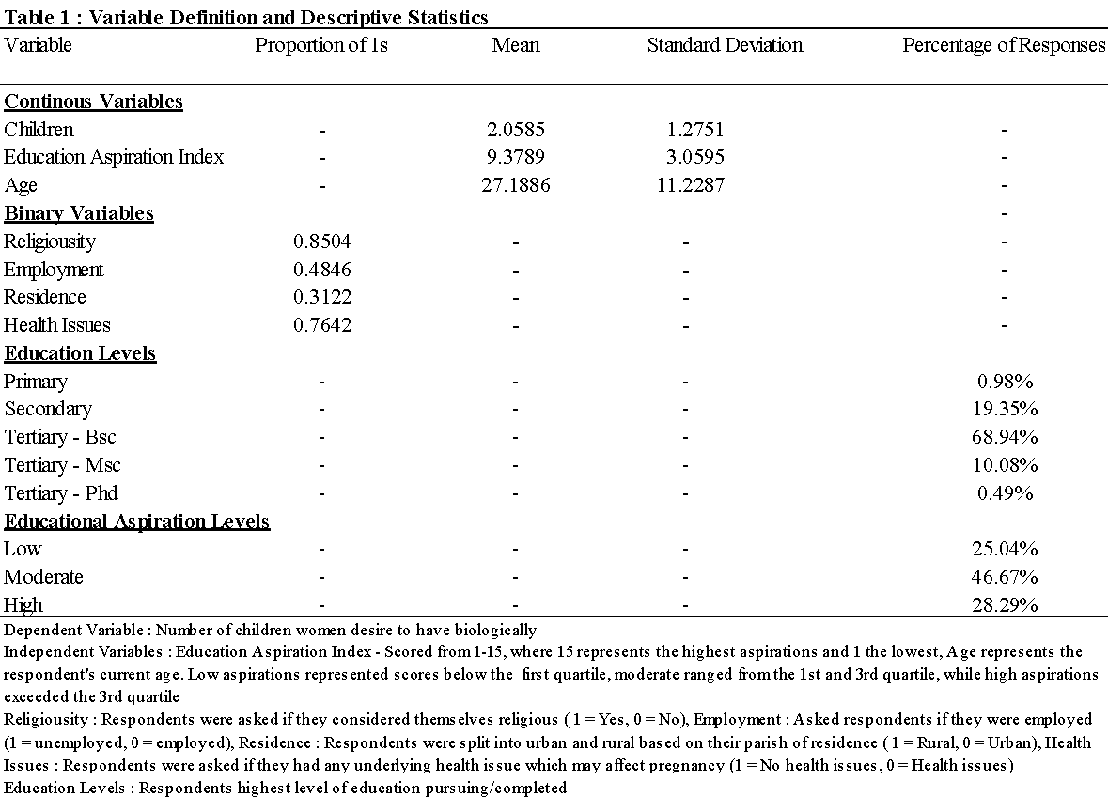

# **Methodology**

This study investigates the intricate relationship between women's educational aspirations and their desired number of children. In like manner to, Fagbamigbe and Adebowale (2014) the researcher included residence, employment, and religion as explanatory variables. In a similar fashion to, Wang and Famoye (1997), A dummy variable for residence was used (1 = Rural, 0 = Urban). Rural residence is expected to be positively related to the number of children women desire to have, given that persons in rural areas tend to have more children than those in urban areas (Kulu, 2013). Similarly, to Adserà (2006), Employment status was also used as a dummy variable (1 = Unemployed, 0 = Employed), however, employment status and its relationship to the number of children women want to have has changed over the years, from being negatively significant to being positively significant (Ahn & Mira, 2002). A religion dummy was also used by Borch et al. (2011), distinguishing between various denominations within Christianity, when exploring the effects that these different subsections have on fertility levels. However, given that within this study the focus is on education/educational aspirations, the religion dummy takes on two values (1 = Religious and 0 = not religious). This is consistent with research from Zhang (2008) which found that religious beliefs have a substantially positive effect on fertility.

The researcher built on previous studies, like East and Barber (2014) and Beal and Crockett (2010) which both utilized two questions on a Likert scale to distinguish between levels of aspiration. However, this research will utilize four different questions, which will be used to create an aspirations index, ranging from low aspirations to high aspirations. The data is moderately skewed**,** thus the median and quartiles were used to distinguish between, low expectations, moderate expectations, and high expectations, given that these measures are best used to describe skewed data. Low expectations were defined as index values that fell below the first quartile, moderate expectations were defined as index values that ranged from the first quartile to the third quartile, and high expectations were defined as index values that were above the third quartile.

The Poisson Maximum Likelihood method of estimation was chosen, due to its ability to effectively capture count data. Under this method, the mean should be relatively close to the variance, which is generally the case with fertility data (Wang & Famoye, 1997). The Poisson distribution is appropriate for non-negative integer data and is particularly useful when data has a right-skewed distribution, which is often the case with fertility data (Poston, 2002).

The Generalized Poisson Regression (GPR) model was used since the count data exhibits underdispersion. The GPR model account is useful where the assumption of the Poisson model is violated, that assumption being the expected value being equal to the variance. The GPR extends the Poisson regression model by introducing an additional dispersion parameter, often denoted as “α”, to account for any extra variability in the data beyond what is assumed by the Poisson distribution.

# **Estimation results and analysis**

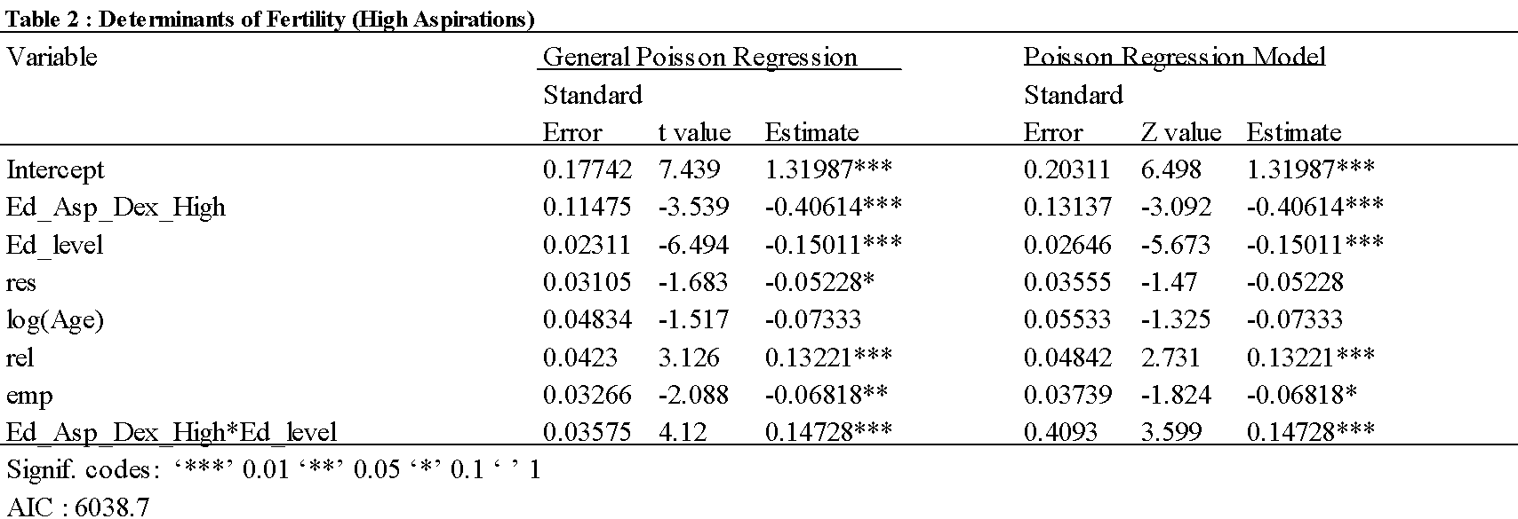The sample is estimated using both the Poisson regression model and the Generalized Poisson regression model. Tables 2,3 and 4 present the estimates, standard errors and z values (in the Poisson model) and t values (in the Generalized Poisson model).

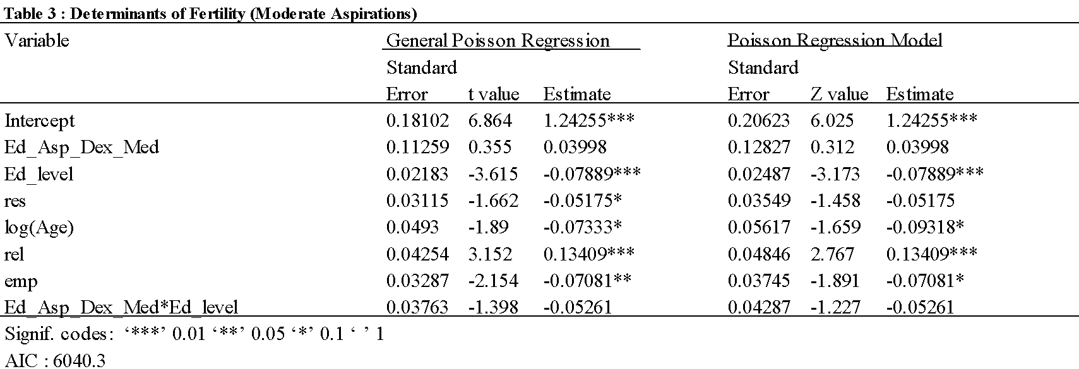

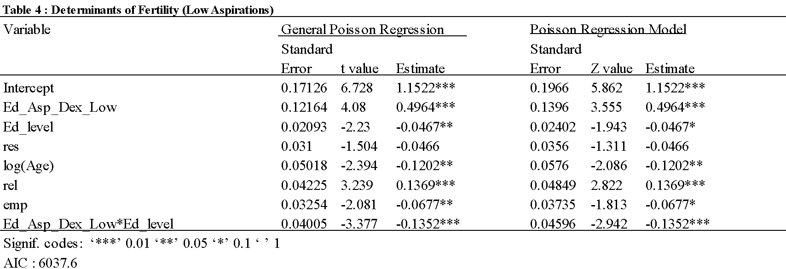

The coefficients in both the Poisson model and the Generalized Poisson model exhibit notable similarity. However, not addressing the issue of underdispersion within the Poisson model led to a consistent overestimation of standard errors compared to the GPR model. Furthermore, the t-values in the Poisson model tended to be downwardly biased in relation to the GPR model. Comparable outcomes were documented by Winkelmann and Zimmermann (1994) in their analysis of German fertility data and by Wang and Famoye (1997) in their examination of United States fertility data, with a focus on Michigan.

Education level remained a consistently significant and negative factor across all three variations of the model, as depicted in Tables 2, 3, and 4. This aligns with the observations of Aldieri and Vinci (2010) and Cherie et al. (2023), suggesting a robust association between educational attainment and desired family size. Notably, the study reveals varying coefficients for different educational aspiration groups, with the largest coefficient associated with the high educational aspirations group and the smallest with the low educational aspirations group.

These findings resonate with the insights put forth by Becker (1991), emphasizing the substantial returns to education in modern economies. The negative relationship between education and desired family size implies that individuals view education as an investment with significant opportunity costs. Pursuing education, especially at advanced levels, demands substantial time and effort. This often involves delayed entry into the workforce, which limits, albeit temporarily, one’s earnings and the ability to provide for a family. Therefore, this investment represents a deliberate choice individuals make, signaling a trade-off between educational pursuits and the decision to have children.

Moreover, the results suggest that as education levels increase, individuals may undergo a shift in preferences regarding family size. Beyond economic considerations, they may prioritize aspects of family life. This may manifest as a focus on providing a superior education for their children and ensuring they enjoy a high standard of living. The decision to have fewer children might be a strategic response to these evolving priorities that accompany higher educational attainment.

With each one-unit increment in high aspirations, we anticipate a decrease of approximately 0.40614 in the logarithm of the expected count of the desired number of children, holding other factors constant. Conversely, the coefficients associated with moderate aspirations did not reach statistical significance, implying that moderate aspirations may not exert a statistically significant impact on the logarithm of the expected count of the desired number of children. In contrast, for low aspirations, a one-unit increase is linked to an approximate increase of 0.4964 in the logarithm of the expected count of the desired number of children. This suggests that women with lower aspirations are inclined to express a higher desired number of children.

These findings align with the research of Alcaraz et al. (2021) and provide empirical support for Huinink and Kohli's (2014) life course perspective theory. According to this theory, shifts in societal norms and parental expectations influence the aspirations of parents, particularly concerning education and the quality of recreational activities. Presently, there exists a societal expectation that parents should provide their children with the utmost levels of educational, cultural, and social capital. Achieving this provision becomes more feasible with higher levels of education, which is often associated with higher income. Consequently, this transformation in parental obligations may induce apprehension among prospective parents, stemming from the perceived risk of being unable to meet the demands of the parental role.

The theory posits that when couples feel personally obligated or are expected by their social circles to adhere to these elevated standards, the likelihood increases that such concerns will significantly impact their decision-making processes, leading to couples and by extension women desiring less children. On the contrary, those who are expected by their social circles to adhere to the standard of having multiple children, increases the likelihood of said persons having more children. Those couples who belong to social groups, where the group is characterised by lower income/education, may be encouraged to have more children, this leads to those couples and by extension women desiring more children.

With a concurrent one-unit increase in both education level and high aspirations, the logarithm of the expected count of the desired number of children demonstrates an approximate increase of 0.14728. This observation implies that the joint presence of high education and high aspirations is linked to an increase in the desired number of children. Conversely, a simultaneous one-unit increase in both education level and low aspirations corresponds to an approximate decrease of 0.1352 in the logarithm of the expected count of the desired number of children. This underscores that the coexistence of higher education and low aspirations is associated with a reduction in the desired number of children.

These results suggest that the connection between education level and the inclination for children is contingent upon the level of aspirations. It is conceivable that women possessing both high aspirations and a high level of education harbour distinct attitudes or prioritize differently, influencing their desired number of children in contrast to women possessing only one of these characteristics.[1] For those with high educational attainment, the pursuit of educational aspirations may not be perceived as an impediment to the number of children they wish to have.

Table 6, Appendix A1 supports this interpretation by revealing a positive coefficient for the interaction term between high education and high educational aspirations, indicating a favourable influence on the desired number of children among women with both characteristics.

These findings are consistent with the Bargaining Power Theory as applied to fertility and household decisions, as discussed by Rasul (2008). The study suggests that women's education influences fertility through various channels, one of which involves elevating the opportunity cost of time. Consequently, in the context of already high education levels, the diminished opportunity cost of time for pursuing further education may elucidate the jointly positive coefficient observed for high education interacting with high aspirations.

Furthermore, if women have reached a particular educational milestone where they experience satisfaction not only in terms of financial remuneration but also in personal fulfilment, the motivation to pursue additional education may diminish. In such instances, individuals may choose alternative routes to achieve contentment, for example by the establishment of a family. This underscores the diverse ways in which individuals seek fulfilment beyond the traditional educational and career trajectories, emphasizing the multifaceted nature of personal contentment.

The residence variable was significant at the 10% level of significance, when considering high and moderate aspirations, as seen in Tables 2 and 3. The positive coefficient associated with this variable suggests that individuals who have predominantly resided in urban areas express a higher desire for children relative to those with a predominant rural residence history. This finding diverges from the results of studies such as Cherie et al. (2023) and Wang and Famoye (1997), both of which identified a trend wherein women in rural areas tended to desire more children compared to their urban counterparts.

Notably, most survey respondents have been exposed to a heightened standard of living, thanks to the advent of technology and widespread use of social media. This exposure extends across both urban and rural environments, revealing disparities from the ideal quality of life when comparing it with both urban and rural living standards. Importantly, the difference between the ideal standard and the reality of rural living is more pronounced than that observed with urban living.

Consequently, women from rural areas may perceive a greater need for sacrifices to bridge this gap and reach the envisioned standard. This perception aligns with the increasing significance and negativity of the coefficient as the aspiration grouping ascends as seen in Tables 2,3 and 4. Hence, women in rural areas, with a larger opportunity cost of time, may express a slightly reduced desire for a certain number of children relative to their urban counterparts. This echoes the life course perspective theory, where the onus is on the parents to provide as high a standard of living as possible for their children.

Furthermore, in contemporary times, women from rural areas may not face the same imperative to have a large number of children for economic sustenance, as they did during earlier periods. Equality legislation and improved access to education and employment opportunities could empower women in rural settings to make choices aligned with their personal aspirations rather than traditional roles. This change in circumstances may contribute to a shift in the desired number of children, with women in rural areas expressing a preference for smaller family sizes.

The negative coefficient attributed to the age variable stands in contradiction to prevalent perspectives on the relationship between age and fertility. Contrary findings by Poston and McKibben (2003) and Wang and Famoye (1997) unveiled a positive correlation between fertility and age. It is imperative to note, however, that the aforementioned studies centered on "children ever born" as the dependent variable, while the present model employs the desired number of children over one's lifetime as the dependent variable. This crucial distinction underscores the heavy contingence of the response variable on one’s current perception.

The reliance on the individual's current perceptions in this model introduces a dynamic element to the analysis. Younger women may indeed express a higher preference for larger family sizes, reflecting immediate aspirations. However, as individuals age, an increased awareness of economic challenges associated with child-rearing emerges. Factors such as healthcare and education costs become salient considerations, instigating a shift in desired family size toward a more pragmatic and feasible lower number of children. This nuanced perspective contributes to the observed negative association between age and the desired number of children, challenging conventional assumptions and underscoring the importance of contextualizing findings within the specific framing of the research question.

Expectedly, religiosity exhibits a positive correlation with the envisioned number of children women desire, a trend consistent with the findings of Zhang (2008) and Skirbekk (2008). The tenets of religious teachings place significant emphasis on familial values, procreation, and the sanctity of life. Consequently, individuals deeply rooted in religious beliefs often perceive the act of having more children as not only a personal choice but also a religious obligation, assisting with the growth of their personal faith.

Moreover, religious communities, characterized by shared values and collective beliefs, foster robust support networks. Within these communal structures, individuals may benefit from various forms of support, including counselling, educational resources, and financial assistance. This communal backing contributes positively to the formulation of desired family sizes among women with strong religiosity, shaping their preferences and choices in alignment with the values espoused by their faith.

As seen in the model, the employment variable also exhibits a negative coefficient, implying that those who are employed, desire more children than those who are unemployed. This contradicts Van Den Broeck and Maertens (2014) and Wang and Famoye (1997). However, those individuals who tend to be more financially stable and have greater access to economic resources can effectively sustain and provide for the children they may have. This may instil a heightened willingness for a larger family size.

In conclusion, the results support the quantity-quality theory, in addition to the life course perspective theory regarding fertility choices.

# **Limitations**

While the present regression model provides valuable insights into the factors influencing the desired number of children among the sampled population, several limitations should be acknowledged. Firstly, the data utilized for this study were gathered through self-reported surveys, introducing the potential for response bias. Participants may be inclined to provide socially desirable responses, impacting the accuracy of the reported information. Furthermore, the model includes a set of predetermined independent variables, yet other unobserved factors may influence fertility desires. The study also categorizes those pursuing a particular level of education with those who have completed said level, this may introduce selection bias. Those who have completed a level might have certain characteristics or experiences that differ from those currently pursuing the same level. Finally, the generalizability of the findings is limited to the specific demographic characteristics of the sampled population. Future research should aim to address these limitations by employing diverse research methods, incorporating longitudinal data, and exploring additional variables that might contribute to a more comprehensive understanding of fertility preferences. Longitudinal data would be essential for examining how preferences for family size evolve.

# **Conclusion**

In conclusion, the study has shed light on the factors influencing the number of children women desire. The analysis revealed that education was inversely related to fertility preferences, in all three models. Moreover, there was a negative and significant association between educational aspirations and fertility preferences. However, when combining the effects of high aspirations with high levels of education, the researcher found a positive relationship between said variable and fertility preferences.

# **Policy recommendations**

In formulating policy recommendations, it is imperative to ensure that the proposed policies not only foster high educational attainment but also contribute to favourable fertility rates, recognizing both as pivotal elements for sustained economic growth and development. The underpinning theories of the quantity-quality model and life course perspective accurately describe the findings, necessitating policies that mitigate the opportunity cost of childbearing while concurrently enabling the provision of a higher standard of living for their children.

Firstly, governmental initiatives can encourage universities to adopt flexible educational policies tailored to the needs of women who prioritize education and having children. This encompasses the introduction of part-time study options, online course offerings, and extended timelines for completing educational programs. Such measures aim to empower women to pursue their educational objectives without succumbing to pressure to defer family planning.

Secondly, government intervention can manifest in the provision of financial support, scholarships, or incentivization programs specifically designed for women undertaking higher education. This strategic approach seeks to alleviate the financial constraints associated with educational pursuits, rendering it more feasible for women to integrate their academic pursuits with considerations of family planning.

Finally, the government can play a pivotal role in instituting supportive workplace policies that cater to the transitional phase from education to the workforce. Policies encompassing flexible work hours, remote work options, and family leave not only accommodate women's commitment to education and career development but also facilitates the integration of their professional and familial responsibilities.

In summation, the outlined policy recommendations underscore the dual importance of promoting educational advancement and favourable fertility rates. By addressing the specific needs of women who value education, these proposals aim to cultivate an environment where individuals can concurrently achieve their educational aspirations and navigate family planning.

# **References**

Adserà, A. (2006). An economic analysis of the gap between desired and actual fertility: the case of Spain. *Review of Economics of the Household*, *4*(1), 75–95. https://doi.org/10.1007/s11150-005-6698-y

Ahn, N., & Mira, P. (2002). A note on the changing relationship between fertility and female employment rates in developed countries. *Journal of Population Economics*, *15*(4), 667–682. https://doi.org/10.1007/s001480100078

Akeju, K. F. (2021). Fertility preference in older women: effect of place of residence and use of contraceptives in Nigeria. *International Journal of Social Sciences Perspectives*, *8*(1), 25–30. https://doi.org/10.33094/7.2017.2021.81.25.30

Al-Balushi, M. S., Ahmed, M. S. M., Islam, M. M., & Khan, H. R. (2020). Multilevel poisson regression modeling to identify factors influencing the number of children ever born to married women in Oman. *Journal of Statistics and Management Systems*, *23*(8), 1357–1373. https://doi.org/10.1080/09720510.2019.1709328

Alcaraz, M., Hayford, S. R., & Glick, J. E. (2021). Desired fertility and educational aspirations: Adolescent goals in rapidly changing social contexts. *Journal of Marriage and Family*, *84*(1), 7–31. https://doi.org/10.1111/jomf.12815

Aldieri, L., & Vinci, C. P. (2010). An Investigation of the Relation between the Number of Children and Education in Italy. *Social Science Research Network*. https://doi.org/10.2139/ssrn.2012414

Becker, G. S. (1960). An economic analysis of fertility. *RePEc: Research Papers in Economics*, 209–240. https://econ.duke.edu/~vjh3/e195S/readings/Becker_Fertility.pdf

Becker, G. S. (1991). A treatise on the family. In *Harvard University Press eBooks*. https://doi.org/10.4159/9780674020665

Borch, C., West, M., & Gauchat, G. (2011). Go Forth and Multiply: Revisiting Religion and Fertility in the United States, 1984-2008. *Religions*, *2*(4), 469–484. https://doi.org/10.3390/rel2040469

Chen, S. (2022). The positive effect of women’s education on fertility in Low-Fertility China. *European Journal of Population*, *38*(1), 125–161. https://doi.org/10.1007/s10680-021-09603-2

Cherie, N., Getacher, L., Belay, A. S., Gultie, T., Mekuria, A., Sileshi, S., & Degu, G. (2023). Modeling on number of children ever born and its determinants among married women of reproductive age in Ethiopia: A Poisson regression analysis. *Heliyon*, *9*(3), e13948. https://doi.org/10.1016/j.heliyon.2023.e13948

Doepke, M., Hannusch, A., Kindermann, F., & Tertilt, M. (2022). The Economics of Fertility: A New Era. *Social Science Research Network*. https://doi.org/10.2139/ssrn.4114800

Fagbamigbe, A. F., & Adebowale, A. S. (2014). Current and predicted fertility using Poisson regression model: evidence from 2008 Nigerian Demographic Health Survey. *PubMed*, *18*(1), 71–83. https://pubmed.ncbi.nlm.nih.gov/24796171

Griliches, Z., & Mason, W. M. (1972). Education, income, and ability. *Journal of Political Economy*, *80*(3, Part 2), S74–S103. https://doi.org/10.1086/259988

Huinink, J., & Kohli, M. (2014). A life-course approach to fertility. *Demographic Research*, *30*, 1293–1326. https://doi.org/10.4054/demres.2014.30.45

Kemkes-Grottenthaler, A. (2003). POSTPONING OR REJECTING PARENTHOOD? RESULTS OF A SURVEY AMONG FEMALE ACADEMIC PROFESSIONALS. *Journal of Biosocial Science*, *35*(2), 213–226. https://doi.org/10.1017/s002193200300213x

Kulu, H. (2013). Why Do Fertility Levels Vary between Urban and Rural Areas? *Regional Studies*, *47*(6), 895–912. https://doi.org/10.1080/00343404.2011.581276

Poston, D. L. (2002). The Statistical Modeling Of The Fertility Of Chinese Women. *Journal of Modern Applied Statistical Methods*, *1*(2), 387–396. https://doi.org/10.22237/jmasm/1036109160

Poston, D. L., & McKibben, S. L. (2003). Using Zero-inflated Count Regression Models To Estimate The Fertility Of U. S. Women. *Journal of Modern Applied Statistical Methods*, *2*(2), 371–379. https://doi.org/10.22237/jmasm/1067645400

Rasul, I. (2008). Household bargaining over fertility: Theory and evidence from Malaysia. *Journal of Development Economics*, *86*(2), 215–241. https://doi.org/10.1016/j.jdeveco.2007.02.005

Singh, K. P., & Famoye, F. (1993). Analysis of rates using a generalized poisson regression model. *Biometrical Journal*, *35*(8), 917–923. https://doi.org/10.1002/bimj.4710350804

*Skewness & Central Tendency*. (n.d.). PennState: Statistics Online Courses. https://online.stat.psu.edu/stat200/lesson/2/2.2/2.2.4/2.2.4.1

Skirbekk, V. (2008). Fertility trends by social status. *Demographic Research*, *18*, 145–180. https://doi.org/10.4054/demres.2008.18.5

Van Den Broeck, G., & Maertens, M. (2014). Does female employment reduce fertility rates? Evidence from the Senegalese horticultural export sector. *2014 International Congress, August 26-29, 2014, Ljubljana, Slovenia*. https://doi.org/10.22004/ag.econ.182715

Wang, W., & Famoye, F. (1997). Modeling household fertility decisions with generalized Poisson regression. *Journal of Population Economics*, *10*(3), 273–283. https://doi.org/10.1007/s001480050043

Winkelmann, R., & Zimmermann, K. F. (1994). Count data models for demographic data∗. *Mathematical Population Studies*, *4*(3), 205–221. https://doi.org/10.1080/08898489409525374

Zhang, L. (2008). Religious affiliation, religiosity, and male and female fertility. *Demographic Research*, *18*, 233–262. https://doi.org/10.4054/demres.2008.18.8

# **Appendix A1**

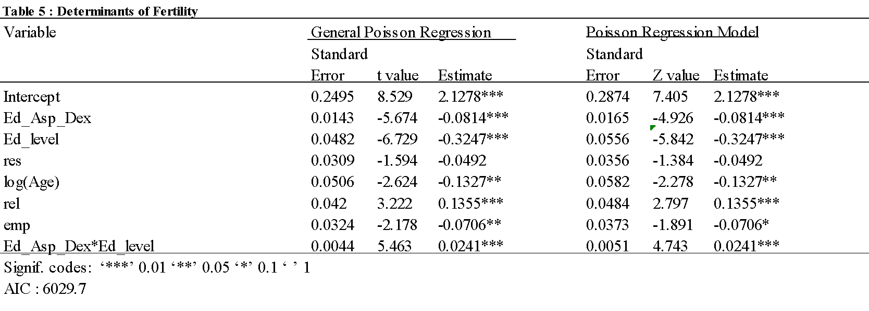

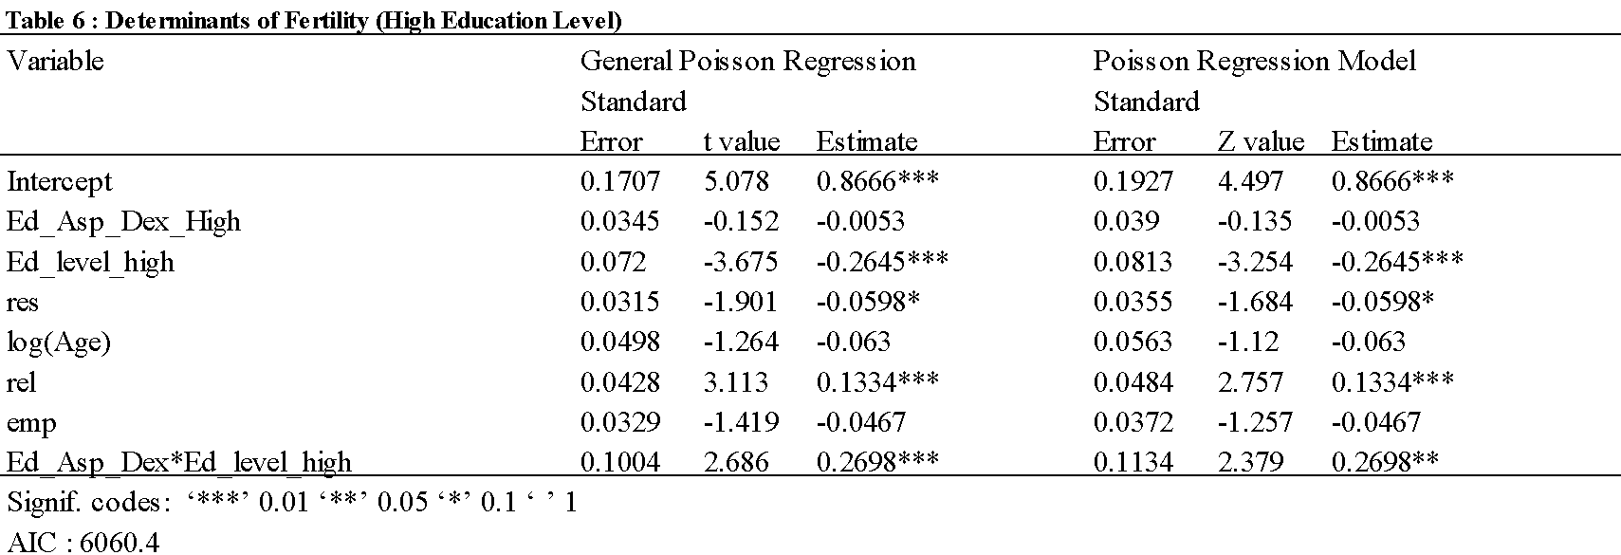

1. High education refers to those who are pursuing or have completed a master’s degree or a PhD. It also includes those who are pursuing or have completed medical school on route to becoming at the very least a general practitioner.